# **Fight predictor Django App**

## **View 1:**

Fighter stats(/fighter/:id)

This view lists all the stats scraped for a fighter from fightmetrics.com like age, height, weight, reach, wins, losses. The fighter shall be a model and the stats shall be his attributes.

Bonus: Display fighter image. Shall be implemented given bandwidth.

## **View 2:**

Fight matches(/fight/:id)

This view lists all the matches in an upcoming UFC event. This data has been downloaded from the UFC API. Clicking the fighters mentioned in the matchups should redirect to the fighter stats(/fighter/:id)

Bonus: Display fighter image. Shall be implemented given bandwidth.

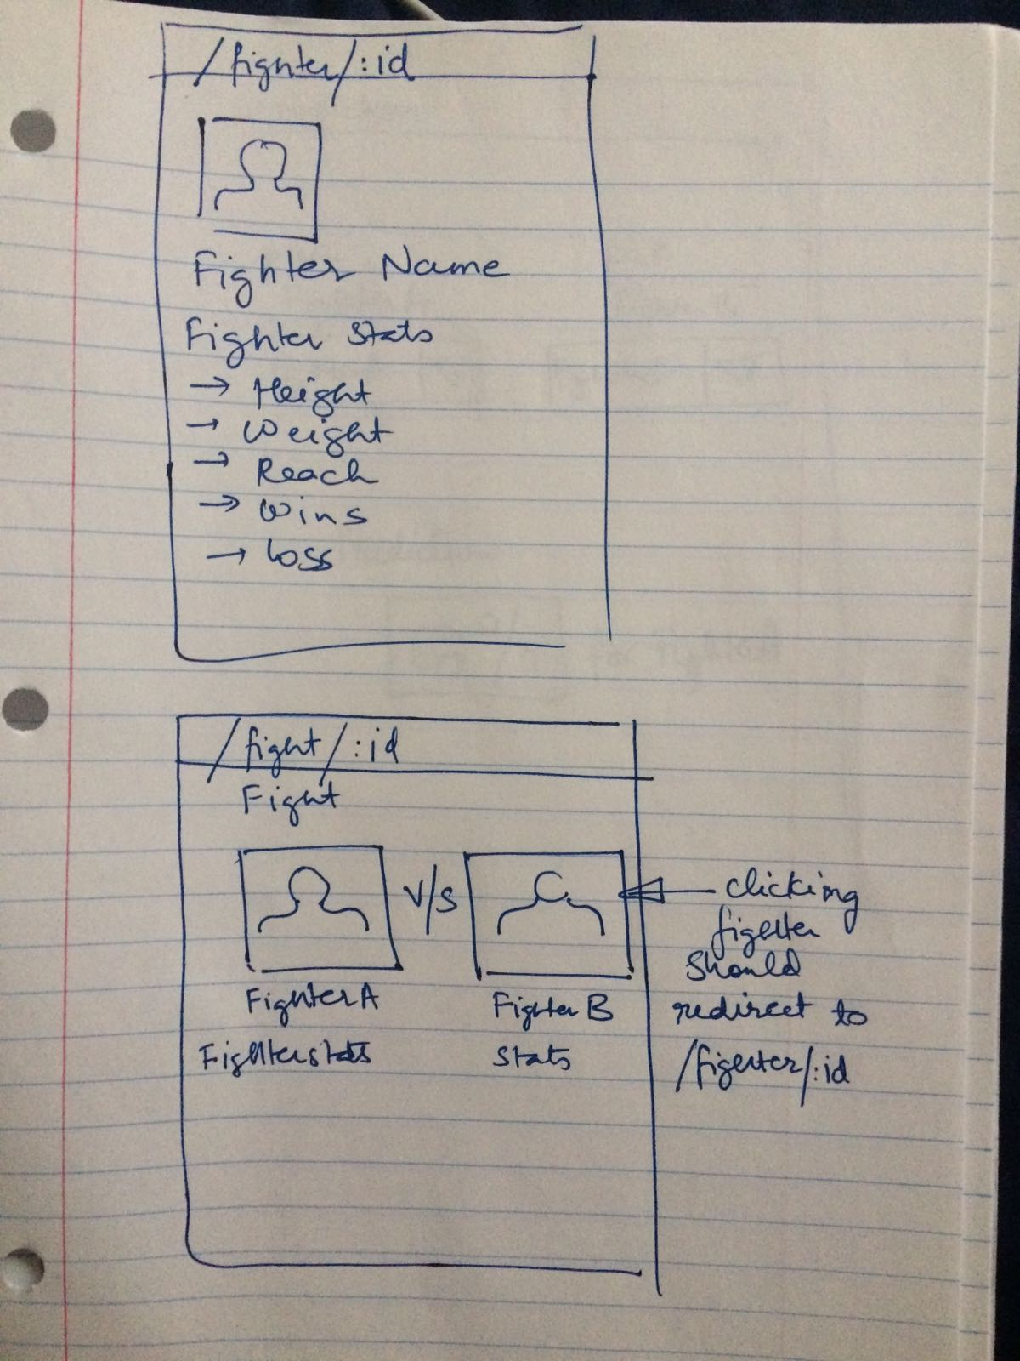

## **View 3:**

prediction(/prediction)

This view shall contain 2 dropdowns, containing all the fighters whose stats we have collected. The user shall choose the fighters from the dropdown in a hypothetical matchup. Our prediction models shall use the stats data collected for the fighters to predict the winning percentage of the fighters(factoring the possibility of a draw/NC).

